EXPERIMENT – 4
- Update the value of student name whose register number is ‘102’
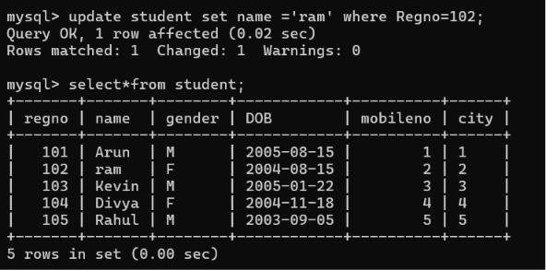

- Delete the record in the table FACULTY, who resigned her job.

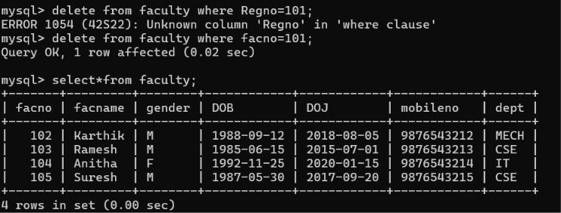

- Modify the age for the faculty whose name is 'Mohan' with a value ‘59’.

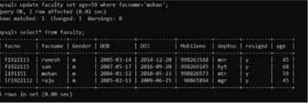

- Remove all faculty who are having over 65 years

